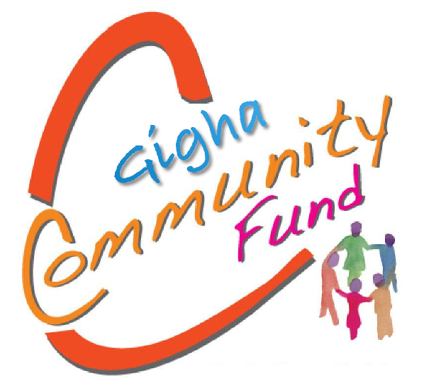

‘to support a thriving and healthy community on Gigha’
School Leaver Application Form
Please read the associated guidance notes before completing this form.
A grant award of £100 is available to Gigha based school leavers moving on to further education, apprenticeship work or other post-school activity.
Your Name:
Address:
Postcode:
Tel: Email:
Date of Birth:
School attended before leaving:
- If you are moving to college/university, please provide full details about your course.

- If you are being taken on as an apprentice or other work related activity, please provide details.

- Do you have a bank or building society account? Yes □ No □
Submission
Please confirm that you have completed everything we have asked. Use the checklist below.
- I have answered all the questions in this application.
- I confirm that I am eligible to apply, as set out in the fund guidance.
- Application has been signed below.
Applicant signature: _________________________

Date: _________________________

Please send your completed application to: shona@gigha.org.uk
Or you can post your application to:
The Isle of Gigha Heritage Trust
Craft Workshop 1
Isle of Gigha
PA41 7AA
Contact Details:
By email: shona@gigha.org.uk or telephone: 01583 505 390

